Tap N Jump

Thank you for purchasing this Game.

This game can be build to android,ios & windows phone 8.
It is strongly recommend to import this package in an empty Project to avoid tag and iTween conflicts.

BUILD SETTINGS

Make sure you added these scenes as per order.

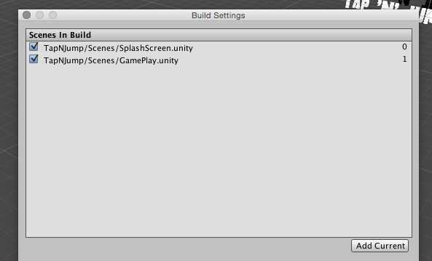

All Scripts are under in Scripts Floder .

Ball (Player ) control is written in playerController.cs.

Total UI translation done in UiContainer.cs.

New bar Group instantiation in GameController .

You will find more descript in the code itself.

if you like this game ,plz give review on assetstore .it helps a LOT.

Support
For Quick questions & support, contact me at kiran.killstreak@gmail.com
Skype ID kirankillstreak

Thanks
Kiran

